LAB ASSIGNMENT-19.2
NAME :M.TANVI
ROLL NO:2403A510A4
COURSE:AI ASSISTED CODING BATCH:01(AIML)

QUESTIONS:
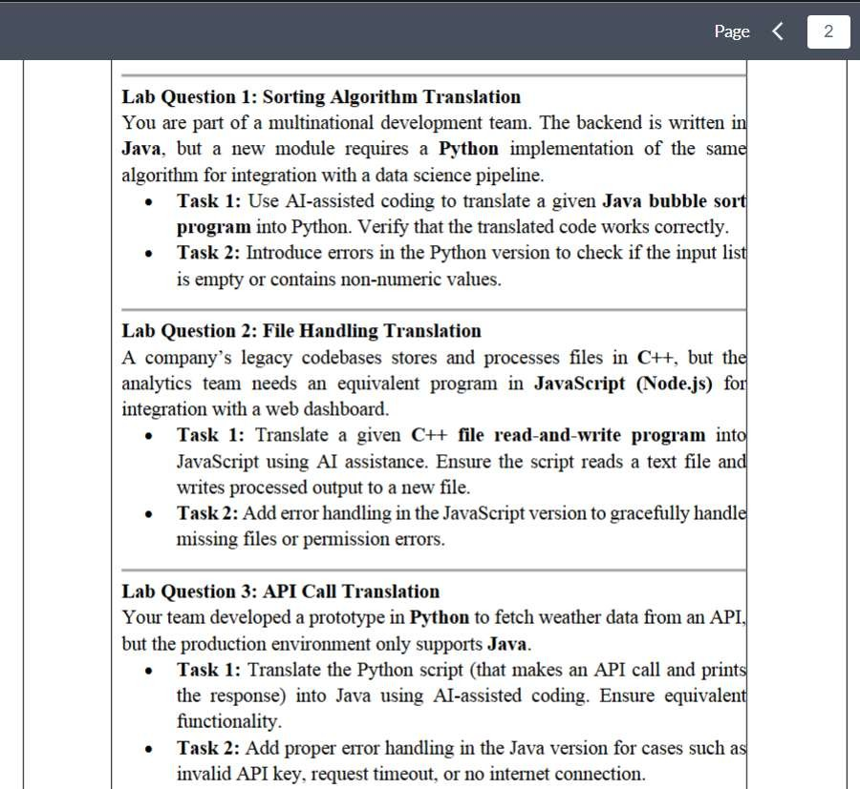

LAB QUESTION 1:
PROMPT:
You are part of a multinational development team.
The backend system uses Java, but a new module requires a Python implementation for integration with a data science pipeline.
Task 1: Use AI-assisted coding to translate the following Java Bubble Sort program into Python and verify that it works
correctly.
Task 2: Modify the Python version to include error handling that checks if the input list is empty or contains non-numeric values. If so, print an appropriate error message instead of sorting.
CODE:
public class BubbleSort {
public static void main(String[] args) { int[] arr = {5, 1, 4, 2, 8};
bubbleSort(arr);
System.out.println("Sorted array:"); for (int num : arr) {
System.out.print(num + " ");
}
}

static void bubbleSort(int[] arr) { int n = arr.length;

for (int i = 0; i < n - 1; i++) {
for (int j = 0; j < n - i - 1; j++) { if (arr[j] > arr[j + 1]) {
int temp = arr[j]; arr[j] = arr[j + 1]; arr[j + 1] = temp;
}
}
}
}
}

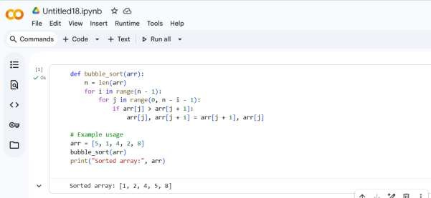

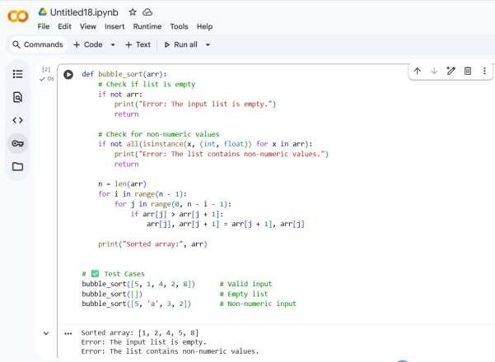

LAB QUESTION 2:
PROMPT:
You are part of a development team that is modernizing a company’s legacy C++ system.
The old system reads a text file, processes its content, and writes the results to a new file.
Task 1: Use AI-assisted coding to translate the given C++ file read-and-write program into JavaScript (Node.js).
Ensure that the JavaScript version correctly reads data from a text file and writes processed output (for example, uppercase text) into a new file.

Task 2

Extend the JavaScript (Node.js) file-handling program by adding error handling.
The updated script should handle missing input files, invalid permissions, or any I/O errors gracefully, showing user-
friendly messages without crashing the program. CODE :
#include <iostream> #include <fstream> #include <string>
using namespace std;

int main() {
ifstream inputFile("input.txt"); ofstream outputFile("output.txt"); string line;

if (inputFile.is_open() && outputFile.is_open()) { while (getline(inputFile, line)) {
outputFile << line << endl;
}
cout << "File has been copied successfully." << endl;
} else {
cout << "Error opening file." << endl;
}

inputFile.close();

outputFile.close();

return 0;
}

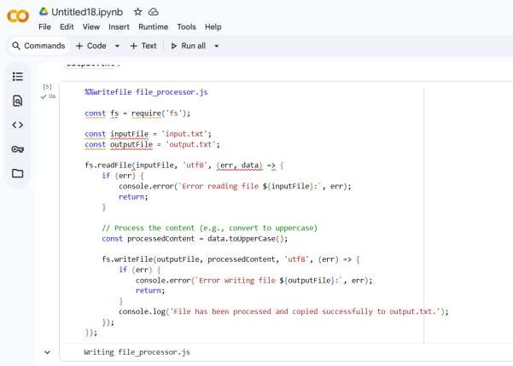

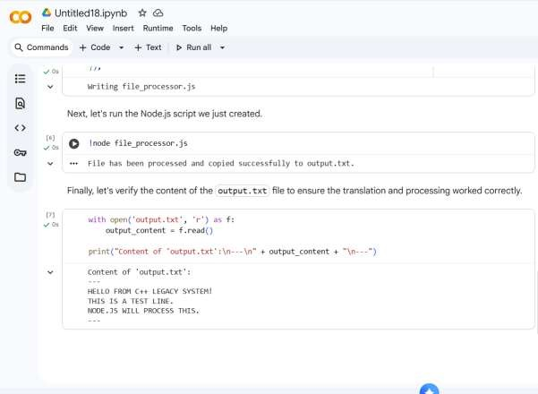

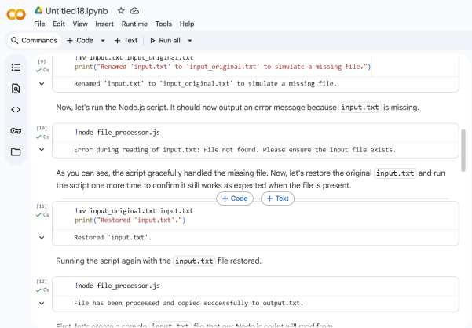

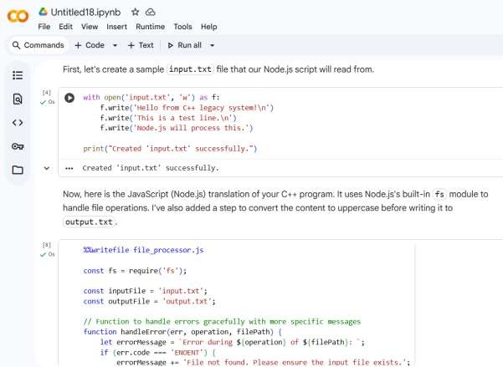
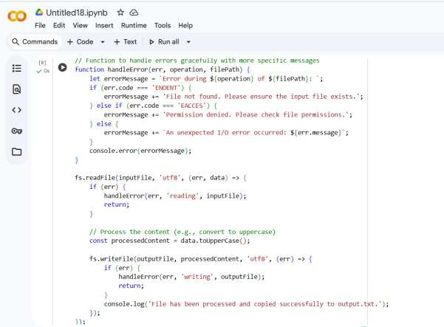

LAB QUESTION 3:
PROMPT:
API Call Translation
You are part of a software development team migrating a data pipeline from Python to Java.
The Python prototype makes an API call to fetch weather data and prints the response.
Task 1: Use AI-assisted coding to translate the following
Python API call program into Java while ensuring equivalent functionality (fetch data and print the JSON response).

Task 2
Extend the translated Java API program to include robust error handling.
The Java version should gracefully handle the following scenarios:
- Invalid API key (HTTP 401)
- Request timeout
- No internet connection or network issues
Print clear error messages for each case without the program crashing.
CODE:
import requests

def get_weather():

api_key = "your_api_key_here" city = "London"
url =
f"http://api.openweathermap.org/data/2.5/weather?q={city}&appid={api_key} "

response = requests.get(url)
if response.status_code == 200:
print("Weather Data:", response.json()) else:
print("Error fetching data:", response.status_code)

get_weather()

